Team Collaboration

You can invite team members, [groups](https://learning.postman.com/docs/collaborating-in-postman/user-groups/), and external users to collaborate in a workspace by navigating to the workspace and selecting **Invite** in the Postman header.

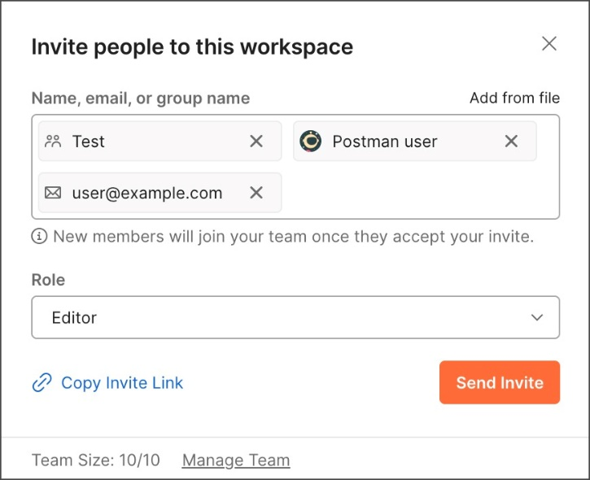

# Workspace roles

**Workspace Admin** - Can invite Postman teammates or external users to personal, private, team, and public workspaces, and assign them a workspace role. If a Workspace Admin invites an external user to a workspace, Postman will share this request with [Team Admins](https://learning.postman.com/docs/collaborating-in-postman/roles-and-permissions/#team-roles). Once approved, an invite to join the team will be sent to the individual.

**Workspace Editor** - Can invite external users to team and public workspaces, but can't assign them workspace roles. For private workspaces, Workspace Editors using the [Postman web app](https://learning.postman.com/docs/getting-started/installation/installation-and-updates/#use-the-postman-web-app) can copy and share a link to the workspace with a teammate, who can then [request access to the workspace](https://learning.postman.com/docs/collaborating-in-postman/using-workspaces/managing-workspaces/#access-private-workspaces).

**Workspace Viewer** - Can't invite teammates to private, team, or public workspaces. For private workspaces, Workspace Viewers using the [Postman web app](https://learning.postman.com/docs/getting-started/installation/installation-and-updates/#use-the-postman-web-app) can copy and share a link to the workspace with a teammate, who can then [request access to the workspace](https://learning.postman.com/docs/collaborating-in-postman/using-workspaces/managing-workspaces/#access-private-workspaces).

# [**Approve requests for access to private workspaces**](https://learning.postman.com/docs/collaborating-in-postman/using-workspaces/managing-workspaces/#approve-requests-for-access-to-private-workspaces)

Team members can request access to a private workspace if another user with access provides them with a link to it. All Workspace Admins will be notified of requests for access by the notifications icon and by email.

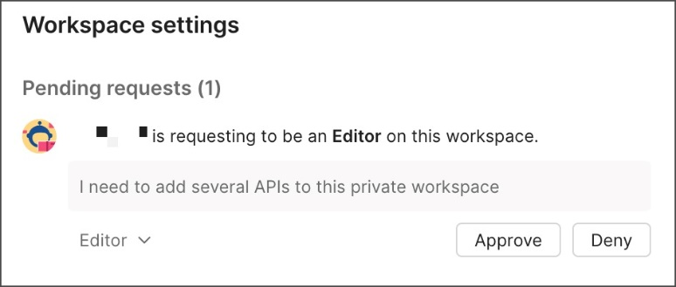

You can assign a workspace role to define a user's permissions within the workspace, then select **Approve** to grant them access.

Note - Requests for access to private workspaces expire if they aren't reviewed within 15 days. If this occurs, Postman will alert the affected users to resubmit their request for access.

# [Watch a workspace](https://learning.postman.com/docs/collaborating-in-postman/using-workspaces/managing-workspaces/#watch-a-workspace)

Watch a workspace to receive an email or in-app notification when a team member modifies the workspace. This includes changing the workspace visibility or updating an element in the workspace.

To start watching a workspace, select Watch icon **Watch** in the workspace's **Overview** tab. Select the count next to **Watch** to access the list of people who are watching the workspace.

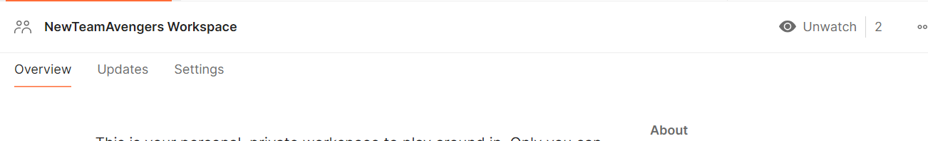

# Comments on APIs

Comments feature is added to bring collaboration within the workspace.

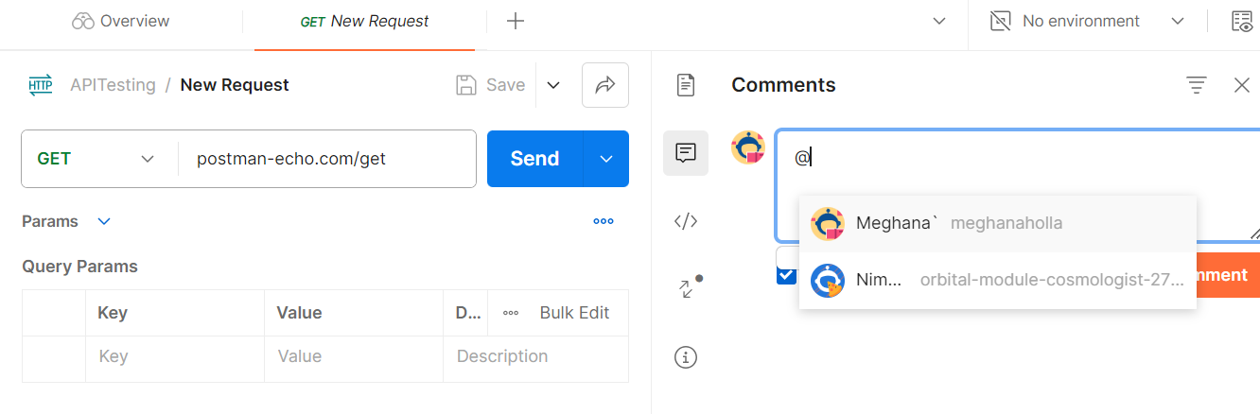

# Announce changes to your API

You can post workspace updates to keep your team aware of changes to your APIs. Workspace updates enable team members to respond and react to your posts.

1. Find the **Updates** tab at the workspace level, between the **Overview** and the **Settings** tabs.

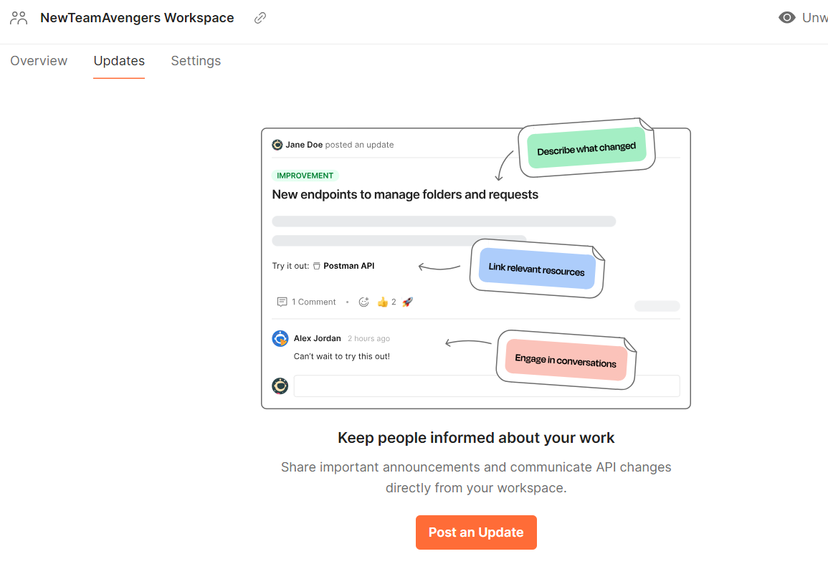

1. Enter a title and a description of your update.
2. Select a tag from the dropdown list: **Improvement**, **New Feature**, **Bug Fix**, **Breaking Change**, or **Announcement**.
3. Select **Link Resource** to include links to collections, requests, and saved examples in your update.
4. Add a summary describing the change.
5. Select **Post Update**.

# Team roles

* **Super Admin** (Enterprise plans only) - Manages everything within a team, including team settings, members, roles, and resources. This role can view and manage all elements in public, team, private, and personal workspaces. Super Admins can perform all actions that other roles can perform.
* **Admin** - Manages team members and team settings. Can also view monitor metadata and run, pause, and resume monitors.
* **Billing** - Manages team plan and payments. Billing roles can be granted by a Super Admin, Team Admin, or by a fellow team member with a Billing role.
* **Developer** - Has access to all team resources and workspaces.
* **Community Manager** (Professional and Enterprise plans only) - Manages the public visibility of workspaces and team profile.
* **Partner Manager** (Internal, Enterprise plans only) - Manages all Partner Workspaces within an organization. Controls Partner Workspace settings and visibility, and can send invites to partners
* **Partner** (External, Professional and Enterprise plans only) - All partners are automatically granted the Partner role at the team level. Partners can only access the Partner Workspaces they've been invited to.
* **Guest** (Internal) - Views collections and sends requests in collections that have been shared with them.

# Change logs

Postman maintains changelogs for collections, workspaces, and APIs. You can use the changelog to review create, update, transfer, and delete actions made by you and your team on private and shared elements.

## View collection activity

To review the changelog for a collection in Postman, open the collection and select the changelog icon Changelog icon.

The changelog provides a chronological list of the collection's activities.

You can view the time and date at which changes occurred, the users who made changes, and the affected parts of the collection.

